**TITLE: Invasive ungulates are major drivers of forest composition in novel ecosystems**

**AUTHORS: Ann Marie Gawel, Haldre S. Rogers, Ross H. Miller, and Alexander M. Kerr**

**KEYWORDS: *ungulates, invasive species, herbivory, seed dispersal, limestone forests, Mariana Islands***

**Abstract**

We investigated the roles of introduced Philippine deer (*Rusa mariannae*) and feral pigs (*Sus scrofa*) on seedling survival, seed dispersal, and plant community structure in the limestone forests of the Mariana Islands of Guam and Rota. We compared fenced and unfenced seedling plots, monitored germination from scat samples, and surveyed vegetation and ungulate sign abundance across sites on both islands. Deer selectively browsed four out of six planted species in seedling plots, and both native and non-native seedling and vine abundance on vegetation transects showed strong negative loglinear correlations (R2 ≥ 0.65) to deer abundance in Guam. Highest plant diversity occurred at intermediate levels of deer disturbance in a quadratic relationship. Plant community characteristics was not significantly correlated to pig abundance, although we recorded germination from many pig scats, with a predominance of native, rather than exotic, plant species. Deer on these islands appear to be major drivers of plant community composition, even in these highly altered systems. Pig presence was not clearly linked to species diversity, although they do act as seed dispersers, which may be beneficial in a system such as Guam that has lost the majority of seed dispersers. The nuances of their ecological roles can better inform management of their populations as well as native forest restoration and conservation in the Mariana Islands.

**Introduction**

The extent of human influence is so pervasive that the earth today is comprised mostly of novel ecosystems (Seastedt et al. 2008). Novel ecosystems have species compositions and relative abundances that have not been previously observed, and usually result from anthropogenic influences (Hobbs et al. 2009). Species introductions create and maintain novel ecosystems by adding new species and removing native species (Seastedt et al. 2008). Novel ecosystems may be severely degraded and comprised of non-native species, but may still harbor species that serve important ecological functions. Many are good candidates for restoration. However, effective conservation in these systems requires better knowledge of the remnant native and introduced species that comprise them, and their current ecological roles.

Most conservation goals focus on restoring native species to historical abundances, but restoring ecological functions may be more beneficial and feasible for degraded ecosystems (Hobbs et al. 2011). Conservation efforts that have focused on removing invasive species and reintroducing native species have yielded many positive results. However, removing invasive species may have negative consequences if these species play important ecological roles in the novel system (Savaleta et al. 2001). Likewise, reintroducing reduced or extirpated native species may prove unsuccessful or detrimental if persistant threats and current conditions are poorly understood (Hobbs et al. 2011, Godefroid et al. 2011).

Although the negative impacts of introduced species are extensive, some introduced species play beneficial roles (Davis et al. 2011, Schlaepfler et al. 2011). Introduced species may be good candidates for restoring severely degraded habitats. For example, planting non-native trees in abandoned pastures in Puerto Rico facilitated the return of native plant communities where the native plants would not have originally colonized (Lugo 1997). Some introduced species may provide desirable ecological functions such as seed dispersal or food sources for native species (Goodenough 2010). Introduced Japanese white-eyes (*Zosterops japonica*) in Hawaii are seed dispersers for native plants that previously relied on now extinct or rare native birds (Foster and Robinson 2007). Finally, invasive species may slow or reverse negative ecological effects from other anthropogenic impacts. Cascading ecological effects from overfishing in Cape Cod salt marshes are being reversed by green crabs (*Carcinas maenas*), which are normally considered a harmful invasive (Bartness and Coverdale 2013).

Feral ungulates are components of novel ecosystems around the world, and although their negative effects are well-documented (Nogueira-Filho et al 2009, Rooney & Waller 2003, Ickes et al. 2001), there are a few examples where they play beneficial roles (Desbeiz et al. 2011, O’Connor and Kelly 2012). Ungulate eradication is an important restoration tool, especially in island environments where ungulates are considered destructive invasive species (Kessler 2002, Spear and Chown 2009). However, invasive ungulates may also fill missing ecological roles in highly degraded island systems; this complexity makes management of ungulates challenging. Pigs have been documented as dispersers of native plant species on islands where they have been introduced (O’Connor and Kelly 2012) and other ungulates such as cattle and sheep effectively control exotic plant species in island habitats (Klinger et al. 1994). If ungulates have been part of a system for a long time, they may play considerable functional roles, such that their removal results in unintended consequences. These include the release of invasive plant species (Cabin et al. 2000, Coomes et al. 2003) or reduced seed-dispersal (O’Connor and Kelly 2012). Natural resource managers would be aided by discerning which non-native species serve important functions, and which species are solely destructive before implementing conservation actions in a novel ecosystem.

The islands of Guam and Rota in the Mariana Archipelago, Western Micronesia, as with many islands around the world, have had a long history of species introductions (Fritts and Rodda 1998). Perhaps the most famous invasive species is the brown treesnake (*Boiga irregularis*), which was unintentionally introduced to Guam and is responsible for the extinction of most of Guam’s native birds between 1945 and 1985 (Savidge 1987). The nearby island of Rota has retained more pristine limestone forest habitats than Guam (Falanruw et al. 1989), however, both islands have experienced many species introductions, including ungulates, which have been established for centuries (Safford 1905, Conry 1989, Wiles et al 1999). Deer and pigs in the Marianas have had substantial negative effects on the forest. Philippine deer (*Rusa* *mariannae*) density in Guam has been correlated with reduced seedling recruitment in some species of native trees (Wheeler 1979, Schreiner 1997). Feral pigs (*Sus scrofa*) are thought to affect seedling recruitment through physical disturbance of the forest floor and through seed predation (Conry 1989, Ickes et al. 2001). However, these impacts are occurring within unique novel rather than pristine ecosystems, therefore a more thorough examination of the role of each species within the larger ecological context is needed to make appropriate management decisions.

We investigate the ecological role of invasive ungulates in a highly degraded novel ecosystem and in a less degraded system with similar biological history. Because Guam’s forests have effectively lost all ecological services provided by avifauna, we were able to discern the relative magnitude of impacts from introduced ungulates between Guam and Rota. In the Mariana Islands, birds are especially important for seed dispersal of a number of native forest species (Haldre? pers comm.) Here, we examine the impact of feral pigs and deer on seedling survival, seed dispersal, and overall plant community composition. We contrast their role in the bird-free forests of Guam to that in the nearby forests of Rota which still maintain avian populations.

**Methods**

*Study Area*

Guam (13.45° N, 144.78° E; 540 km2) is the largest and southernmost island of the Mariana Island Archipelago in the Western Pacific. Rota (14.15° N, 145.21° E; 85 km2) is located 76 km north of Guam and has less than 2% of the population of Guam. Both islands have large areas of native karst limestone forest with similar species compositions. These islands contain a variety of habitat types, but karst limestone forests were chosen as the focus of this study because they contain a larger variety of native and endemic tree species relative to other habitats, such as savannah or ravine forest (Fosberg 1960, Raulerson and Rinehart 1991).

*Effect of ungulates on seedling survival*

To assess ungulate effects on seedling mortality, we set up paired plots in karst limestone forest sites in northern Guam and in Rota. We selected eight sites in northern Guam and seven sites in Rota. At each site, we erected a 1.8-m tall chicken-wire fence around one plot, and left the adjacent plot unfenced, allowing ungulate access. The fenced and unfenced plots were placed in areas with similar in canopy cover, rockiness, and surrounding vegetation. Each seedling plot covered an area of about 3.5 m x 5.5 m (Figure 1).

We selected six species for this experiment encompassing a variety of common native and introduced trees found in limestone forests of the Mariana Islands: *Carica papaya*, *Morinda citrifolia*, *Neisosperma oppositifolia*, *Aglaia mariannensis*, *Premna obtusifolia*, and *Psychotria mariannensis*. For each species we collected seeds from at least five trees and at least four different sites to minimize maternal effects and effects of local adaptation. The date of seed collection and subsequent out-planting was staggered by species, in part due to differences in fruiting phenology. After seeds were collected, fleshy fruit was removed, and they were planted in a mixture of 50% perlite and 50% peat moss, and fertilized using Osmocote®. All seeds were planted on the island from which they were collected. The seed trays were placed under 60% shadecloth at a nursery in Guam and at a nursery in Rota, and allowed to grow in these conditions until they had fully rooted and grown their first true leaves. At this point, the seedlings were transported to the exclosure sites for out-planting.

Seedlings of each species were brought to each site and out-planted in the control and treatment areas on the same day. Seedlings were placed at least 0.3 m apart from each other, and at least 0.5 m away from the fences in fenced treatments (Figure 1). On Guam, 14 seedlings of each species were planted in each treatment at each site, except for *N. oppositifolia*, which had only 7 seedlings planted per treatment. This gave a total of 1232 seedlings planted in Guam. In Rota, nine seedlings of *N. oppositifolia*, 11 seedlings of *C. papaya*, and 14 seedlings of the other four species were planted in each treatment at each site, a total of 1190 seedlings. We were not able to get 14 seedlings for every treatment at every site on each island due to seed availability in the wild. The seedlings planted during drier months (*C. papaya, M. citrifolia,* and *N. oppositifolia*) were watered regularly during the first few weeks following transplanting to ensure they successfully established. After transplanting, seedlings were monitored monthly for survival until July 2011 (15 months after the first species was transplanted). We recorded any evidence of ungulate-caused damage or mortality in planted seedlings.

Seedlings were placed at least 0.3 m apart from each other, and at least 0.5 m away from fences in fenced treatments (Figure 1). Seven seedlings of *N. oppositifolia* and 14 seedlings of the other five species were planted in each treatment at each site, for a total of 1232 seedlings in Guam. In Rota, nine seedlings of *N. oppositifolia*, 11 seedlings of *C. papaya*, and 14 seedlings of the other four species were planted in each treatment at each site, for a total of 1190 seedlings. The seedlings planted during drier months (*C. papaya, M. citrifolia,* and *N. oppositifolia*) were watered regularly during the first few weeks after transplantation. After transplanting, seedlings were monitored monthly for mortality.

*Germination from scats*

We collected scats from *R. marianna* and *S. scrofa* from limestone forest sites to determine if either ungulate dispersed viable seeds via endozoochory. Location and date were recorded for each collection. We collected throughout the year, through both rainy and dry seasons. Collections occurred at four different sites in northern Guam where scats from both deer and pigs were abundant.

Scat samples were layered on top of a 50% perlite and 50% peat moss soil mix in germination trays. The trays were kept outdoors at a nursery under shadecloth. *R. marianna* pellets were mixed in at the surface, and *S. scrofa* scats were broken up and mixed at the surface. Trays were watered regularly before and after seedlings emerged from scats. Seedlings were then identified and counted. Because the nursery was open air, species that were known to be wind-dispersed or that were common to all germination trays in the nursery (including from other experiments) were not counted.

*Vegetation transects and scat counts*

We conducted vegetation surveys to gather community composition data about limestone forest sites across Guam and Rota. We surveyed vegetation at each site using two 50-m by 1-m transects (Figure 2), covering a total of 100 m2. At sites with exclosures, transects extended from opposite corners of the exclosure. At sites without exclosures, transects were placed end to end. All plants within the belt transects were identified and recorded. Height was approximated for each adult plant, seedlings were identified and counted, epiphytes were identified on adult plants, and plants were categorized as vines, trees, ferns, or herbs.

In addition to vegetation surveys, scats from both *S. scrofa* and *R. marianna* were counted to estimate relative abundance for each across the sites. After surveys at the initial sites, seven additional sites in Guam were added to increase variation in ungulate abundance, and to include additional karst limestone forest area on Andersen Air Force Base. One exclosure site in northern Guam was excluded, as it did not provide enough forest area to run 100 m2 of transect line. A total of 14 sites were surveyed in Guam.

Because animal tracks are almost impossible to see in karst limestone forest terrain, and the detectability of other sign such as trails and grazing vary widely even in similar habitats, we determined scat to be the most reliable indicator of ungulateabundance (Schreiner 1997). Scats from *S. scrofa* and *R. marianna* were counted along the vegetation transects. A GPS device was used to walk roughly 400 meters in a square around the vegetation transect area (Figure 2), covering an area of about 800 m2. Scats were identified to ungulate species and counted in a 2-meter belt.

*Statistical analyses*

Seedling survival was compared for each planted species.between fenced and unfenced plots. ,using generalized linear models with mixed effects (R statistical software, R Development Core Team 2011). In these linear models, the fixed effects were fencing, species, and island, while site was considered a random effect. Factors were sequentially removed to determine their importance to the simplest fitted model. Species had a strong effect on survival, and it interacted with fencing to affect survival (Table 2). We therefore analyzed species separately with island and fencing treatments as fixed effects and site as a random effect. Factors were considered to have a significant effect on seedling survival if they improved AIC scores by more than -2 (Burnham and Anderson 2004) when included in a linear model.

The identity and abundance of all species germinated from scats are presented in Table 4. Analysis focused on germination from pig scats, which had significantly more frequent germination when compared to deer scats. This was determined using a binomial test (R statistical software, R Core Development Team 2011). Selectivity was estimated using indices prescribed in Manly *et al.* (1993) using the abundances of species that germinated from scat compared to their abundances in nature represented by data from vegetation surveys.

To determine if pigs exhibited selectivity for either native or exotic species that germinated from scat, we collected scat from two sites and compared them to vegetation surveys from those same sites. The majority of scat came from two sites, “Ritidian Gate” on the Guam National Wildlife Refuge, and “Anao North” in the Anao Conservation Area. We calculated the Manly Selectivity Index (Manly et al*.* 1993) for native and for exotic species at each site as:

*B = wi / ∑ wj*,

where *wi* is the selection probability determined by

*wi = ui / πi,*

where *u*i is the proportion of seedlings from scat of either native or exotic seedlings amongst all seedlings from scats from that site, and *πi* is the proportion of native or exotic adult plants at the site. Because nearly all fern spores are dispersed by wind (Tryon 1970), they were excluded from this analysis. Upper and lower confidence intervals for *wi* were calculated by using

*se(wi) =1.96 √{(1 - πi) / (utotπi)}.*

We used linear regression to correlate ungulate scat abundance to forest characteristics measured on vegetation transects. We could not combine pig and deer abundances because sign counts are not comparable due to potentially different and unknown rates of defecation and decomposition. Therefore, we used deer abundance and pig abundance as separate independent factors, and forest characteristics as dependent factors. The forest characteristics investigated were total seedling abundance, native seedling abundance, exotic seedling abundance, vine abundance, and Shannon diversity (Shannon 1948). We tested for outliers using Bonferroni outlier tests. P-values for studentized residuals less than 0.05 were considered outliers. The most extreme values all had Bonferroni P-values greater than 0.05, and so all data were included in analyses. R2 and P-values for each regression were determined using linear models in. To select the best-fit linear models, F-statistics and P-values were also calculated. All calculations and tests were performed using R statistical software (R Core Development Team 2011).

**Results**

*Do ungulates affect forest recruitment?*

Seedling survival in seedling plots varied depending on species, island where they were planted, and fencing treatment. Treatment effects, or exposure to ungulates by planting in unfenced plots, decreased seedling survival significantly in four out of the six species planted (Table 2, Figure 3). Survival was significantly lower in unfenced or ungulate-accessible plots for *C. papaya*, *M. citrifolia*, *P. obtusifolia*, and *P. mariannensis* (Table 3, Figure 3). Treatment had no significant effect on *A. mariannensis* or *N. oppositifolia*. Treatment and island had a significant interaction for *A. mariannensis*, although there was no difference between treatments for this species. Treatment and island also had a significant interaction for *P. mariannensis*, which had lower survival in ungulate plots in Guam, but no difference between treatment plots in Rota.

*Do ungulates act as seed-dispersers?*

We collected a total of 20 deer scats (pellet groups) and 31 pig scats from a number of karst limestone forest sites. Because very few seedlings emerged from the deer scats, analysis was focused on pig scats, and germination from deer scats is thus only briefly described here. Only four of the 20 deer scats collected had seedlings that appeared to have germinated after endozoochory. One scat had eight *C. papaya* seedlings and one scat had one *Passiflora suberosa* seedling. The other species that germinated were one *Vitex parviflora*, and one *Mikania micrantha*, whose seed may have blown into the seedling tray (ISSG 2012). Alternatively, the seed could have been ingested accidentally, as this species does not have an edible fruit.

A greater abundance and diversity of seedlings emerged from collected pig scats. To determine if germination was significantly different between pig and deer scats, a binomial test was run between the total number of seedlings (11) from the 20 deer scats and the total number of seedlings (802) from 20 randomly selected pig scats. P < 0.001 for k = 11 successes.

Of the 31 pig scats collected from four different sites, 25 scats had seedlings (80.6%), with a total of 1657 seedlings successfully germinating. The species that germinated from pig scats were the native trees *M. citrifolia*, and *Ficus prolixa,* the introduced trees *C. papaya* and *Leucaena leucocephala*,and the introduced vines *Passiflora* spp.*, Chromolaena odorata* and *Coccinia grandis* (Table 4). All of these except for *C. odorata* and *L. leucocephala* have edible, fleshy fruits.

In this analysis, the stark differences in selectivity *B* between native and exotic species for both sites (Figure 4), and high significance (Table 5) indicate strong selection for native species dispersal. This should not be interpreted as an actual dietary preference of pigs, but the result of a combination of factors that include pig dietary preferences, the abundance of seeds per fruit and fruit per tree, and the likelihood of survival after being digested. The *w* and *B* values strongly indicate selection for native species at both sites (Table 5). All have fleshy and abundant fruits on each plant, and both *M. citrifolia* and *C. papaya* have large numbers of seeds per fruit.

*How does ungulate abundance relate to forest community composition?*

We used scat counts for deer and pigs to estimate relative abundance amongst sites. Deer scat counts varied greatly between the fourteen sites surveyed in Guam, indicating a wide variation in deer abundance between the sites. Deer scat counts in Rota varied less amongst the seven sites surveyed, all of which had scat counts smaller than the maximum value in Guam.

Strong negative loglinear relationships were detected between the following forest characteristics and deer abundance: total seedling abundance (R2 = 0.710, P < 0.001) (Figure 5A), native seedling abundance (R2 = 0.648, P < 0.001) (Figure 5B), exotic seedling abundance (R2 = 0.770, P < 0.001) (Figure 5B), and vine abundance (R2 = 0.751, P <0.001) (Figure 5C). No associations were detected between these community characteristics and deer abundance in Rota, and no associations were detected between these characteristics and pig abundance. Shannon diversity *H’* had a significant quadratic relationship with deer abundance only in Guam (R2 = 0.516, P = 0.019) (Figure 5D). There were no significant associations between pig abundance and plant diversity in either Guam or Rota.

**Discussion**

Our results show complicated interactions between introduced ungulates and plant communities in the degraded novel ecosystems in Guam, and in the less degraded ecosystems of Rota. Seedling plot experiments on both islands revealed selective browsing on a sample of common forest species by deer. Deer abundance in Guam’s native forests showed strong negative loglinear relationships with overall seedling abundance, including both native and exotic seedling abundance, and vine abundance. We also found that overall plant diversity is greatest at intermediate levels of deer abundance, consistent with the intermediate disturbance hypothesis (IDH) (Connell 1978). We did not detect these relationships with pig abundance, suggesting that deer may have a stronger role in determining species abundance and dispersal in these forests. However, pigs did appear to have a strong role in seed dispersal in Guam, selectively dispersing native seedlings.

Our results show that deer, even at low levels of abundance, maintain novel ecosystem conditions in Guam by inhibiting regeneration of both native and exotic seedlings. The negative relationships we found between forest characteristics and deer abundance (Figure 5) demonstrate that forests are heavily impacted, across all but extremely low deer abundances. This corroborates studies in other systems, such as in North America where densities of native white-tailed deer (*Odocoileus viginianus*) at populations only slightly higher than historic levels limited forest regeneration of once common forest species (Alverson et al 1988.). Therefore, only drastic reductions or elimination of deer are likely to lead to noticeable changes in forest communities.

Deer also had important effects on overall forest community diversity, with the greatest forest diversity at intermediate levels of deer abundance (Figure 5D). This pattern of plant diversity is consistent with the intermediate disturbance hypothesis (IDH) (Connell 1978). The IDH proposes that at low levels of disturbance, as is caused by ungulate herbivory, a few competitive dominants rule, while at high levels of disturbance, only disturbance-tolerant species survive. In contrast to our results, many studies about ungulate effects on biodiversity show a pattern of monotonic decline (Stockton *et al.* 2005, Spear and Chown 2009). One of the few studies of herbivory that did support the IDH model involved deer, and was restricted to ground-cover in a temperate forest habitat. However, the pattern was only evident when other environmental factors were controlled (Suzuki *et al.* 2012). Our study, in contrast, showed an IDH pattern in forest community diversity as a response to deer herbivory, even with other environmental factors at play.

With the high population densities of deer in Guam (Knutson and Vogt 2002), selective herbivory on seedling of some species could have strong implications for species composition of forests, especially combined with the loss of avian ecological functions in Guam. In North American silvicultural treatments, species resistant to deer herbivory thrive with high populations of white-tailed deer, while preferred tree species decreased in the presence of deer (Horsley et al. 2003). We suspect that this is happening in Mariana Island forests with deer as well. Very few studies have looked at which species are preferred by deer in the Marianas (Wheeler 1979). Further stomach-content analyses may reveal which species are selectively browsed by deer and in what quantities. This, combined with long-term vegetation monitoring, could shed light on whether ungulate-impacted forests with few to no birds dispersing seeds will begin shifting to a community composition favoring species that are resistant to deer herbivory and species not reliant on avian seed dispersal.

Feral pigs are notorious for having detrimental effects on plant communities in different ecosystems, so we were surprised that we could not detect relationships between forest characteristics and pig abundances. This may have to do with our indicator of abundance – scat counts may not be an accurate portrayal of relative pig abundances across sites (Andersen and Stone 1994). However, it is also possible that pigs play a smaller role in determining forest community composition than deer do. A previous analysis of pig diet in Guam found foliage to comprise a relatively small portion of stomach contents compared to fruits and invertebrates (Conry 1989). The direct herbivory on seedlings characteristic of deer behavior may have a more noticeable effect on seedling survival than frugivory and uprooting by pigs in areas with both species of ungulates.

Pigs appear to play a role in seed dispersal for both native and exotic species; although they selectively disperse native species, they do not make up for the lost avian seed dispersal in Guam. Studies in Hawaii have implicated pigs not only of inhibiting forest regeneration (Katahira 1980, Nogueira-Filho et al. 2009), but of indirectly affecting native plants by selectively dispersing invasive plants (Aplet et al 1991). In contrast, although some invasive species were found in scats collected in Guam, pigs selectively dispersed native species like *Morinda citrifolia* and *Ficus prolixa*. With the loss of avian and fruit bat (Pteropodidae) seed dispersal in Guam due to the invasive brown treesnake and overhunting (citation for fruit bat overhunting?), pigs may be the major remaining dispersers for fruit trees in Guam. This still leaves many of Guam’s native tree species, majority of which were historically vertebrate dispersed, without a mode of dispersal.

Forests of the two adjacent islands had different responses to ungulate herbivory. Unlike in Guam, we did not observe any association between seedling abundance and deer abundance in Rota. The continued presence of avian seed dispersal in Rota may have obscured any noticeable declines in seedling abundance by improving seedling survival even with the pressure of deer herbivory. Other studies have observed complementary roles of herbivory and seed dispersal (Janzen 1984, Myers et al. 2004), but focus on one species responsible for both herbivory and dispersal. We speculate that multiple species may be determining forest composition through a combination of herbivory and seed dispersal. Seedling mortality was higher in Rota for both fenced and unfenced treatments (Table 2), suggesting that an additional factor unimportant in Guam might be affecting seedling survival in Rota. The cause of this greater mortality is unclear, but we speculate that slug herbivory is responsible. We noticed a particularly high abundance of exotic slugs (Veronicellidae) at our sites in Rota. Slugs extensively damaged native plants in some areas of Hawaii (Joe and Daehler 2008).

Multiple ecological factors such as avian loss, invasive plants, and invertebrate herbivores make it difficult to predict the results of ungulate management, but this study provides a better understanding of their role and the likely impacts of various management options. Whether their roles are interpreted as positive or negative, ungulates are major parts of Guam and Rota’s ecosystems, and their removal or control is likely to have complicated results. Information from this study is important for formulating ecosystem management plans in the Marianas. For example, deer suppression would have to first reach a level low enough to elicit responses from plant communities, so low-level hunting pressure does not appear to be an effective tool for controlling deer herbivory. Enhanced suppression or eradication would be needed for recovery if deer control were deemed a priority for recovering native plant species. If deer suppression is achieved, invasive vines might become a problem when released from herbivory. Pig control or eradication could also have unwanted effects by disrupting what is likely the only vertebrate-facilitated seed dispersal in Guam. Ungulates and snakes might never be eradicated, but ecosystems can still be managed to maintain some native species and functions based on our developing knowledge of novel ecosystem interactions such as these.

**Literature Cited**

Alverson, W.S., D.M. Waller, and S.L. Solheim. 1988. Forests too deer: edge effects in Northern Wisconsin. Conservation Biology. **2**: 348-358.

Anderson, S.J. and C.P. Stone. 1994. Indexing sizes of feral pig populations in a variety of Hawaiian natural areas. Transactions of the Western Section of the Wildlife Society. **30**: 26-39.

Aplet, G.H., S.J. Anderson, and C.P. Stone. 1991. Association between feral pig disturbance and the composition of some alien plant assemblages in Hawaii Volcanoes National Park. Vegetatio **95**: 55-62.

Bartness, M.D. and T.C. Coverdale. 2013. An invasive species facilitates the recovery of salt marsh ecosystems. Ecology **94**: 1937-1943.

Burnham, K. P. and D.R. Anderson. 2004. [Multimodel inference: understanding AIC and BIC in Model Selection](http://www.sortie-nd.org/lme/Statistical%20Papers/Burnham_and_Anderson_2004_Multimodel_Inference.pdf). Sociological Methods and Research **33**: 261-304.

Cabin, R.J., S.G. Weller, D.H. Lorence, T.W. Flynn, A.K. Sakai, D. Sandquist, and L.J. Hadway. 2000. Effects of long-term ungulate exclusion and recent alien species control on the preservation and restoration of a Hawaiian tropical dry forest. Conservation Biology **14**: 439-453.

 Connell, J.H. 1978. Diversity in tropical rain forests and coral reefs. [Science](http://en.wikipedia.org/wiki/Science_(journal)) **199**: 1302–1310.

Conry, P. 1989. Ecology of the wild (feral) pig (*Sus scrofa*) on Guam. Technical Report 7. Division of Aquatic and Wildlife Resources, Department of Agriculture, Guam.

Coomes, D.A., R.B. Allen, D.M. Forsyth, and W.G. Lee. 2003. Factors preventing recovery of New Zealand Forests following control of invasive deer. Conservation Biology. **17**: 450-459.

Desbiez, A.L.J., A. Keuroghlian, U. Piovezan, and R.E. Bodmer. 2011. Invasive species and bushmeat hunting contributing to wildlife conservation: the case of feral pigs in a Neotropical wetland. Oryx. **45**: 78-83.

Falanruw, M.C., T.G. Cole, and A.H. Ambacher. 1989. Vegetation Survey of Rota, Tinian, and Saipan, Commonwealth of the Northern Mariana Islands. Resource Bulletin PSW-RB-27, USDA Forest Service, Pacific Southwest Forest and Range Experiment Station, Berkeley, CA.

Fosberg 1960 The Vegetation of Micronesia, 1: General Descriptions, the Vegetation of the Mariana Islands, and a Detailed Consideration of the Vegetation of Guam. Bulletin of American Museum of Natural History. **119:** 53-75.

Foster, J.T., and S.K. Robinson. 2007. Introduced birds and the fate of Hawaiian rainforests. Conservation Biology. **21**: 1248-1257.

Fritts, T.H., and G.H. Rodda. 1998. The role of introduced species in the degradation of island ecosystems: a case history of Guam. Annual Review of Ecology and Systematics. **29**: 113-140.

Godefried, S., et al. 2011. How successful are plant species reintroductions? Biological Conservation. **144**: 672-682.

Hobbs, R.J., E. Higgs, J.A. Harris. 2009. Novel ecosystems: implications for conservation and restoration. Trends in Ecology and Evolution. **24**: 599-605.

Hobbs, R.J., L.M. Hallett, P.R. Ehrlich, and H.A. Mooney. 2011. Intervention ecology: Applying ecological science in the twenty-first century. Bioscience. **61**: 442-450.

Horsley, S.B., S.L. Stout, D.S. DeCalesta. 2003. White-tailed deer impact on the vegetation dynamics of a northern hardwood forest. Ecological Applications. **13**: 98-118.

Ickes, K., S. J. Dewalt, and S. Appanah. 2001. Effects of native pigs (*Sus scrofa*) on woody understorey vegetation in a Malaysian lowland rain forest. Journal of Tropical Ecology. **17**: 191-206.

Davis, M. et al. 2011. Don’t judge species on their origins. Nature. **474**: 153-154.

Goodenough, A.E. 2010. Are the ecological impacts of alien species misrepresented? A review of the “native good, alien bad” philosophy. Community Ecology. **11**: 13-21.

ISSG (Global Invasive Species Database). 2005. *Mikania micrantha* Species Profile. Available from <http://www.issg.org/database/species/ecology.asp?si=42> Accessed September 27, 2013.

Janzen, D.H. 1984. Dispersal of small seeds by big herbivores: foliage is the fruit. The American Naturalist. **123**: 338-353.

Joe, S.M. and C.C. Daehler. 2008. Invasive slugs as under-appreciated obstacles to rare plant restoration: evidence from the Hawaiian Islands. Biological Invasions **10:** 245-255.

Katahira, L. 1980. The effects of feral pigs on a montane rain forest in Hawaii Volcanoes National Park. In:Smith, C.W. (ed) Proceedings of the third conference in Natural Sciences. University of Hawaii Press, Honolulu, pp 173–178.

Kessler, C. 20 Eradication of feral goats and pigs and consequences for other biota on Sarigan Island, Commonwealth of the Northern Mariana Islands. pp. 132-140 in Turning the tide: the eradication of invasive species (eds. C.R. Veitch and M.N. Clout). IUCN, Gland Switzerland and Cambridge, UK.

Klinger, R.C., P. Schuyler, and J.D. Sterner. 1994. The response of herbaceous vegetation and endemic plant species to the removal of feral sheep from Santa Cruz Island, California. pp. 141-154 in Turning the tide: the eradication of invasive species (eds. C.R. Veitch and M.N. Clout). IUCN, Gland Switzerland and Cambridge, UK.

Knutson, K., and S. Vogt. 2002. Philippine deer and feral pig sampling on northern Guam. Report for Andersen Air Force Base Civil Engineering Fleet, Environmental Division.

Lugo, A.E. 1997. The apparent paradox of reestablishing species richness on degraded lands with tree monocultures. Forest Ecology and Management. **99**: 9-19.

Manly BFJ, L.L. McDonald, D.L. Thomas. 1993. Resource selection by animals. Chapman & Hall, London. 221 pp.

Myers, J.A., M. Vellend, S. Gardescu, and P.L. Marks. 2004. Seed dispersal by white-tailed deer: implications for long-distance dispersal, invasion, and migration of plants in eastern North America. Oecologia. **139**: 35-44.

O’Connor, S., and D. Kelly. 2012. Seed dispersal of matai (*Prumnopitys taxifolia*) by feral pigs (*Sus scrofa*). New Zealand Journal of Ecology. **36**: 228-231.

Nogueira-Filho, S.L.G., Nogueira, S.S.C., and Fragoso, J.M.V. 2009. Ecological impacts of feral pigs in the Hawaiian Islands. Biodiversity Conservation. **18**: 3677-3683.

O’Dowd, D., P.T. Green, and P.S. Lake. 2003. Invasional ‘meltdown’ on an oceanic island. Ecology Letters. **6**: 812-817

R Development Core Team (2011). R: A language and environment for statistical computing. R Foundation for Statistical Computing, Vienna, Austria. ISBN 3-900051-07-0, URL http://www.R-project.org/.

Raulerson, R. and A. Rinehart. 1991. Trees and Shrubs of the Northern Mariana Islands. Coastal Resources Management, Saipan, Northern Mariana Islands. 120 pp.

Rooney, T.P. and D.M. Waller. 2003. Direct and indirect effects of white-tailed deer in forest ecosystems. Forest Ecology and Management. **181**: 165-176

Russell, F.L., D. B. Zippin, and N. L. Fowler. 2001. Effects of white-tailed deer (*Odocoileus virginianus*) on Plants, Plant Populations and Communities: A Review. American Midland Naturalist. **146**: 1-26

Safford, W.E. 1905. Useful Plants of Guam (Facsimile Edition Reprint). p. 76. Guam: Jillette Leon Guerrero / Guamology Publishing.

Savidge, J. 1987. Extinction of an island forest avifauna by an introduced snake. Ecology **68**: 660-668.

Schlaepfer, M.A., D.F. Sax, and J.D. Olden. 2011. The potential conservation value of non-native species. Conservation Biology. **25**: 428-437.

Schreiner, I. 1997. Demography and recruitment of selected trees in the limestone forest of Guam in relation to introduced ungulates. Micronesica **30**: 169-181.

Seastadt, T.R., R.J. Hobbs, and K.N. Suding. 2008. Management of novel ecosystems: are novel approaches required? Frontiers in Ecology and the Environment. **6**: 547-553.

Shannon, C.E. (1948) A mathematical theory of communication. Bell System Technical Journal **27**: 379– 423.

Spear, D. and S.L. Chown. 2009. Non-indigenous ungulates as a threat to biodiversity. Journal of Zoology **279**: 1-17

Stockton, S.A., S. Allombert, A.J. Gaston, and J. Martin. 2005. A natural experiment on the effects of high deer densities on the native flora of coastal temperate rain forests. Biological Conservation **126**: 118–128.

Suzuki, M., T. Miyashita, H. Kabaya, K. Ochiai, M. Asada, and Z. Kikvidze. 2012. Deer herbivory as an important driver of divergence of ground vegetation communities in temperate forests. Oikos. **122:** Online preview available from <http://onlinelibrary.wiley.com/journal/10.1111/(ISSN)1600-0706/earlyview> accessed May 31, 2012.

Tryon, R. 1970. Development and evolution of fern floras of oceanic islands. Biotropica. **2**: 76-84.

Wheeler, M.E. 1979. The biology of the Guam deer. Technical Report 3. Aquatic and Wildlife Resources Division, Department of Agriculture, Guam.

Whitaker, R.J. and S.H. Jones. 1994. The role of frugivorous bats and birds in the rebuilding of a tropical forest ecosystem, Krakatau, Indonesia. Journal of Biogeography **21:** 245-258.

Wiles, G.J., D.W. Buden, and D.J. Worthington. 1999. History of introduction, population status, and management of Philippine deer (*Cervus mariannus*) on Micronesian Islands. Mammalia **63**: 193-215.

**Tables**

**Table 1.** Species in seedling plots.

|  |  |  |  |  |  |  |
| --- | --- | --- | --- | --- | --- | --- |
| **Species** | **Month planted** | **N per plot Guam** | **N per plot Rota** | **Native/ Introduced** | **Documented as food item** | |
| **Deer** | **Pigs** |
| *Carica papaya* | Apr 10 | 14 | 11 | Introduced | seeds, fruit (MW) | fruits (PC) |
| *Morinda citrifolia* | Jul 10 | 14 | 14 | Native |  | fruits (PC) |
| *Neisosp. oppositifolia* | Jun 10 | 7 | 9 | Native |  |  |
| *Premna obtusifolia* | Dec 10 | 14 | 14 | Native | seeds, foliage(MW) | fruits (PC) |
| *Aglaia mariannensis* | Nov 10 | 14 | 14 | Endemic to Marianas | not a preferred species (GW) |  |
| *Psych. mariannensis* | Mar 11 | 14 | 14 | Endemic to Marianas |  |  |

**GW:** Wiles et al 1999; **MW:** Wheeler 1979; **PC:** Conry 1989

**Table 2.** AIC values for combined species models for seedling plots. Species, and the interaction between species and treatment, improved AIC scores significantly (by > 2). Removing them increased AIC scores, indicated by ∆AIC.

|  |  |  |  |  |
| --- | --- | --- | --- | --- |
| **Fixed Effects** | **Interactions** | **Factor removed** | **AIC** | **∆AIC** |
| species, island, fencing | species x fencing, island x fencing | None | 776.7 |  |
| species, island, fencing | island x fencing | species x fencing | 790.9 | 14.3 |
| island, fencing | island x fencing | species, species x fencing | 1072.7 | 296.0 |

**Table 3.** Significant effects and interactions in generalized linear mixed models. Likelihood ratio tests were used to select the best fit model. For four out of six species, the best model (indicated by **) included treatment by fencing.

|  |  |  |  |
| --- | --- | --- | --- |
| **Species** | **Effects** | **AIC** |  |
| *Aglaia mariannensis* | full | 75.79 |  |
|  | no treatment | 77.27 |  |
| *Carica papaya* | full | 134.7 |  |
|  | no treatment | 182.4 | ** |
| *Morinda citrifolia* | full | 130.1 |  |
|  | no treatment | 141.3 | ** |
| *Neisosperma oppositifolia* | full | 76.05 |  |
|  | no treatment | 74.51 |  |
| *Premna obtusifolia* | full | 95.69 |  |
|  | no treatment | 108.4 | ** |
| *Psychotria mariannensis* | full | 71.98 |  |
|  | no treatment | 88.06 | ** |

**Table 4.** List and counts of species germinated in scats.A variety of species germinated from deer (n = 20) and pig scats (n = 31).

|  |  |  |  |  |  |  |
| --- | --- | --- | --- | --- | --- | --- |
|  | **Species** | **Native/Exotic** | **Seedlings per deer scat** | **deer scats with** | **Seedlings per pig scat** | **pig scats with** |
| Vines | *Passiflora suberosa* | Exotic | 0.05 | 1 | 0.42 | 20 |
| *Mikania micrantha* | Exotic | 0.05 | 1 | 0 | 13 |
| *Coccinia grandis* | Exotic | 0 | 0 | 0.13 | 0 |
| Trees | *Morinda citrifolia* | Native | 0 | 0 | 33.58 | 3 |
| *Ficus prolixa* | Native | 0 | 0 | 7.97 | 0 |
| *Carica papaya* | Exotic | 0.4 | 1 | 8.45 | 3 |
| *Leucaena leucocephala* | Exotic | 0 | 0 | 0.03 | 1 |
| *Vitex parviflora* | Exotic | 0.05 | 0 | 0 | 3 |
| Shrubs | *Chromolaena odorata* | Exotic | 0 | 0 | 0.03 | 1 |
| Totals |  |  |  | 4 |  | 25 |

**Table 5.** Significance for Manly Selectivity Index values. Significant *χ2* values indicated selection occurred for seedlings from pig scats.

|  |  |  |  |  |  |  |  |
| --- | --- | --- | --- | --- | --- | --- | --- |
| **Site** | **Native / Exotic** | **n nature** | **prop. nature** | **n scat** | **prop. scat** | **χ2** | **P** |
| Anao North | exotic | 23 | 0.225 | 7 | 0.015 | 114.719 | <0.001 |
| Anao North | native | 79 | 0.775 | 447 | 0.980 |  |  |
| Ritidian Gate | exotic | 37 | 0.607 | 272 | 0.244 | 611.749 | <0.001 |
| Ritidian Gate | native | 24 | 0.393 | 841 | 0.756 |  |  |

**Figures**

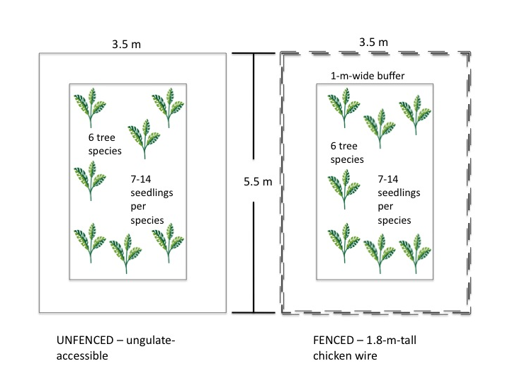

**Figure 1.** Design and dimensions of seedling plots.Seedlings of six different species of trees were planted in paired plots. Paired plots are not necessarily next to one another, but within 10 m of each other.

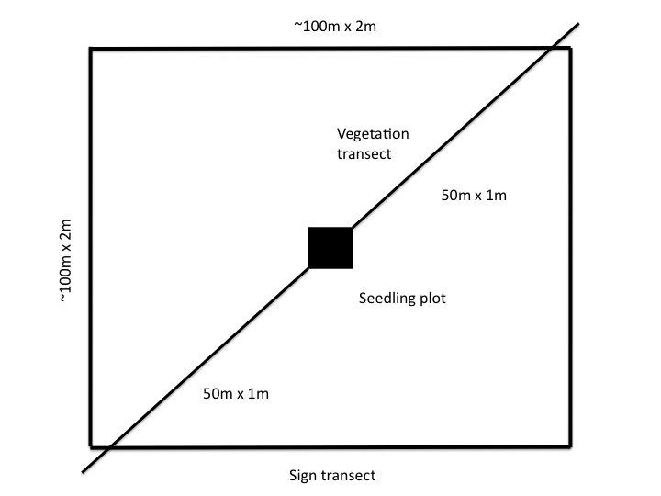

**Figure 2.** Design and dimensions of vegetation and ungulate-sign transects. Two 50-m by 1-m transects were used to survey vegetation. Scats and other ungulate sign were counted along these transects and additional walking transects, in approximately a 100-m by 100-m square. The opaque square in the center depicts the seedling-plot exclosure that was present at most, but not all, of the sites.

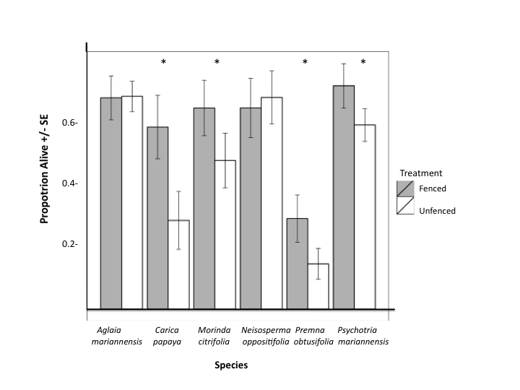

**Figure 3.** Survival in seedling plots.Treatment by fencing or removing ungulate access affected seedling survival, indicated by “proportion alive.” Error bars show one standard error of the mean. Significant effect on seedling survival based on log likelihood ratio test of models with and without treatment.

**Figure 4.** Manly Selectivity Index values (*B*) for native and exotic plants. Manly Selectivity Index values were higher for native species in pig scats collected from Anao North and Ritidian Gate. Error bars represent 95% CI calculated for *B*.

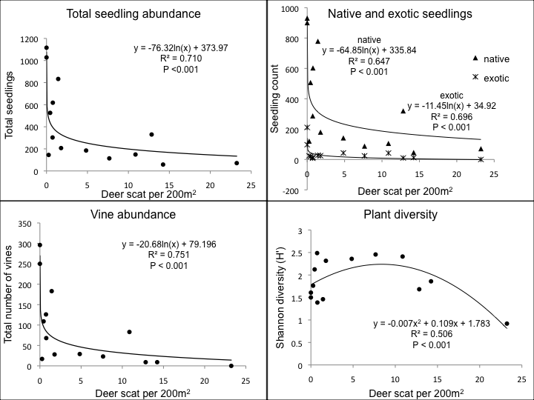

**Figure 5.** Native and exotic seedling abundances, vine abundance, and plant diversity, as measured by Shannon diversity (*H’*) and their relationships to deer abundances across sites, estimated using scat counts.